Capstone 1
Torque Titans
Project documentation
Abstract
This project focuses on the development of a non-motorized vehicle equipped with a rocker-bogie suspension system, designed to navigate heavy terrain effectively. The objective was to create a lightweight, durable, and cost-efficient vehicle while adhering to strict dimensional and functional constraints. Through comprehensive research, various suspension systems were evaluated, with the rocker-bogie system being selected for its superior adaptability to uneven surfaces. The project encompassed conceptual design, 3D modeling, and fabrication of components while integrating sustainable practices like the use of recycled materials. The final outcome is a robust prototype capable of handling challenging terrains while maintaining stability and ease of assembly.
Inroduction
Suspension systems play a critical role in vehicular stability and mobility, particularly for off-road and space exploration vehicles. These systems ensure the vehicle can traverse uneven terrain while maintaining traction, stability, and user control. This project explores the application of advanced suspension designs, specifically the rocker-bogie system, which has proven its effectiveness in planetary rovers like NASA's Mars rovers.
The primary objective of this project is to design, fabricate, and document a non-motorized vehicle with a focus on functionality, durability, and adherence to strict dimensional and budgetary constraints. The design process involved evaluating various suspension systems, selecting the most suitable one based on a decision matrix, and iteratively refining the design through prototypes. This documentation outlines the research, design methodology, fabrication processes, and key decisions that led to the successful completion of the project.
Literature review on suspensions
Suspension systems are very important for all vehicles, especially for off-road and space exploration vehicles. These systems help to keep the vehicles stable, absorb shocks, handle rough movements and maintain traction on rough surfaces. This review explains different types of suspension, their usage in off-road vehicles on Earth, and how they are adapted for Mars and Moon rovers.

Types of Suspension Systems
Here are the two main categories of suspensions which are used in automotive industry.

Dependent Suspension
This system connects both wheels on the same axle. It is also called solid axle or live axle suspension, one of the simpler suspension systems. It is strong and is used in older vehicles, heavy-duty and off-road vehicles. The support comes from leaf springs or coil springs. They can handle tough conditions and are the primary suspension systems for rear-wheel-drive automobiles, and SUVs.
- Advantages: durability, simplicity and cost-effectiveness
- Disadvantages: limited wheel articulation, reduced comfort and uneven tire wear
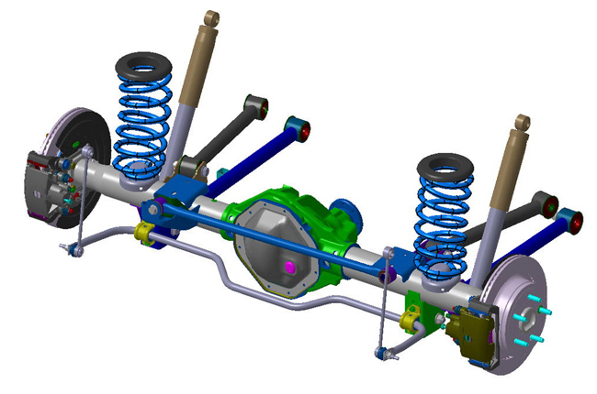
1. Figure: Dependent suspension

Independent Suspension
Independent suspension is popular in modern vehicles due to handling, comfort, and stability. This suspension type allows each wheel to move vertically independently of the others. It typically consists of a combination of control arms, shock absorbers, springs, and connecting links. It is common for the left and right sides of the suspension to be connected with anti-roll bars or other such mechanisms. The anti-roll bar ties the left and right suspension spring rates together but does not tie their motion together.
- Advantages: improved handling, enhanced comfort, reduced tire wear, ability to customize
- Disadvantages: complexity, higher cost, space requirements
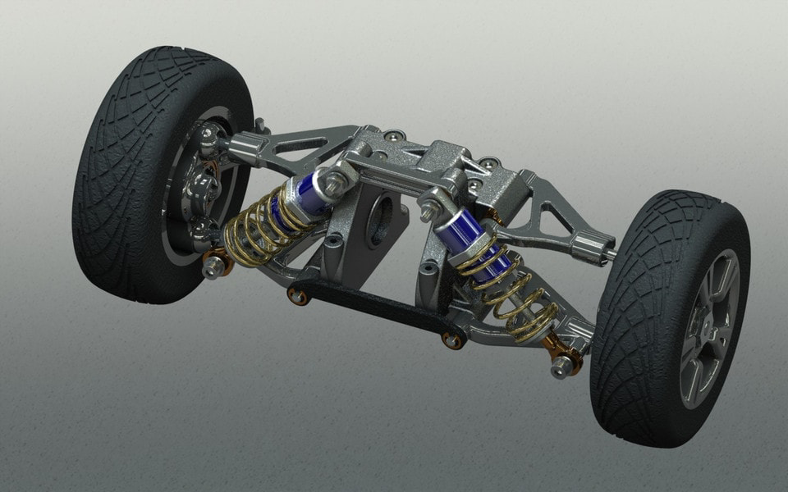
2. Figure: Independent suspension

Suspension of Off-Road Vehicles
Off-road vehicles need strong suspension to handle rough and uneven ground. Some common types are:

Multi-link Suspensions:
A multi-link suspension is a type of independent vehicle suspension having three or more control links per wheel. These arms do not have to be of equal length and may be angled away from their "obvious" direction. Used in high-performance off-road vehicles to allow better wheel movement and flexibility.
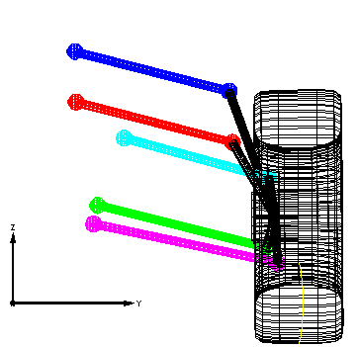
3. Figure: Movement of Multi-link suspension
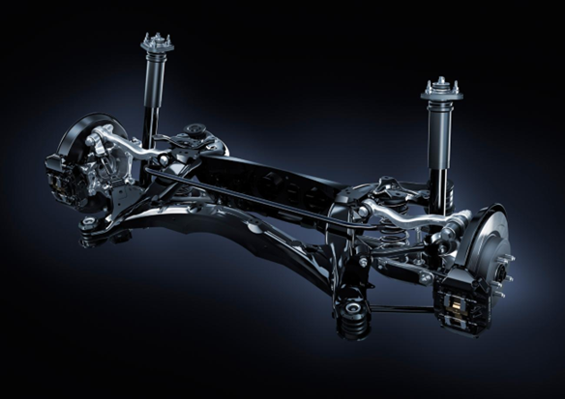
4. Figure: Multi-link suspension

Long Travel Suspension:
It is often used in off road racing. Vehicles such as dune buggies, baja racers, mountain bikes, adventure motorcycles, dirt bikes and rock clawers use long travel suspension to dampen the effects of rough, off-road driving conditions. It helps the vehicle keep traction on bumpy surfaces.

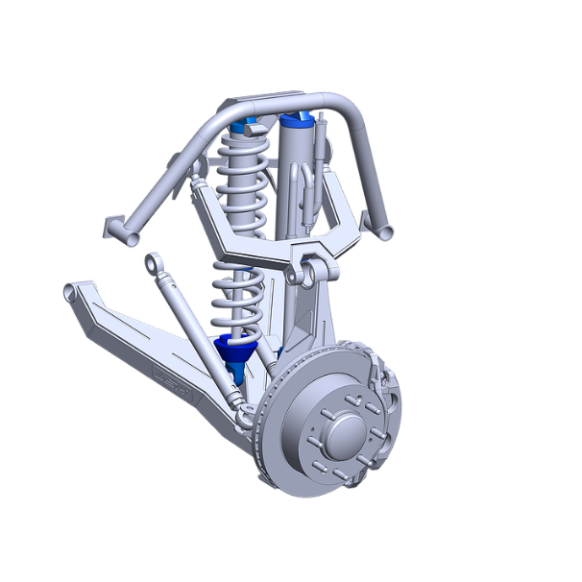
5. Figure: Long Travel suspension

Hydropneumatic Suspensions:
These systems can adjust their height and damping to improve ride quality.
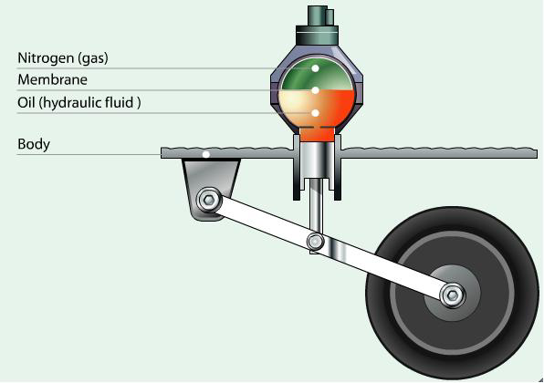
6. Figure: Hydropneumatic suspension

Air Suspensions:
Air suspension is a type of vehicle suspension powered by an electric or engine-driven air pump or compressor. This compressor pumps the air into a flexible bellows, usually made from textile-reinforced rubber. Unlike hydropneumatic suspensions, which offer many similar features, air suspension does not use pressurized liquid, but pressurized air. The air pressure inflates the bellows and raises the chassis from the axle. The purpose of air suspension is to provide a smooth, constant ride quality, but in some cases is used for sports suspension. Air suspension is used in place of conventional steel springs in heavy vehicle applications such as buses and trucks, and in some passenger cars.
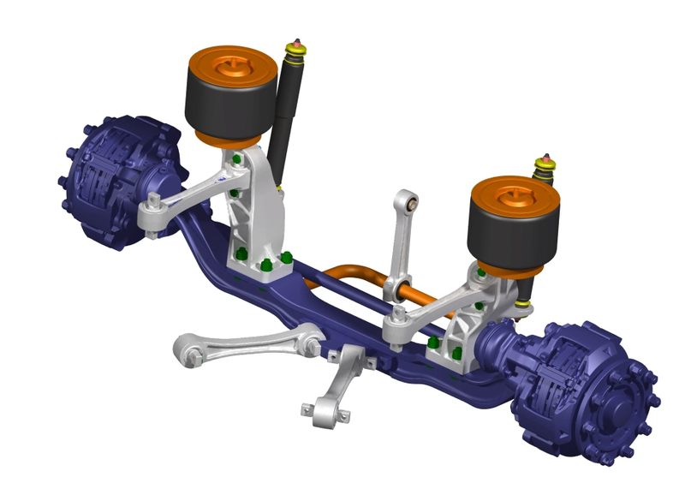
7. Figure: Air suspension

Leaf Sping Suspensions:
It consists of stacked metal strips (leaf springs) that absorb shock and support the vehicle's weight. The springs flex to absorb bumps and uneven surfaces. This system is durable, cost-effective, and well-suited for heavy-duty vehicles like trucks and vans due to its strong load-carrying capacity and distribution. However, it can provide a rougher ride compared to more advanced suspensions like coil springs or air suspensions. Leaf spring suspensions are simple, reliable, and commonly used in commercial, military and off-road vehicles.
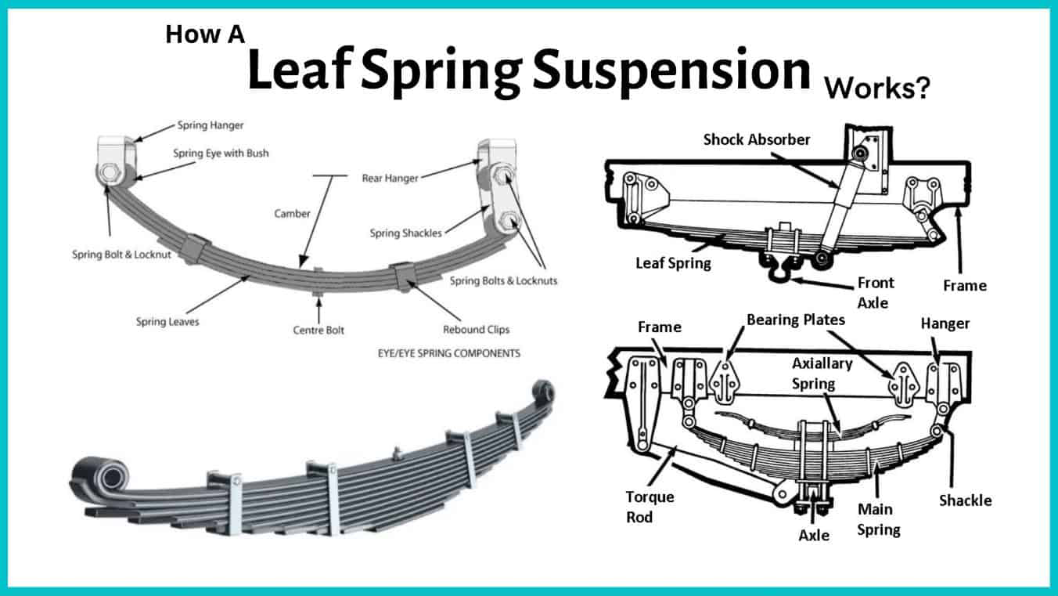
8. Figure: Leaf Spring suspension

Suspension in Planetary Rovers
Mars and Moon rovers face unique challenges, such as low gravity and rocky, sandy surfaces.

Rocker-Bogie System
The rocker-bogie system is the suspension arrangement developed in 1988 for use in NASA's Mars rover Sojourner, and which has since become NASA's favored design for rovers. It consists of two main parts: a rocker arm and a bogie arm, connected by a central pivot. Each wheel is attached to a bogie arm, and the rocker arm allows the wheels to move independently, ensuring all wheels stay in contact with the ground. This system provides excellent stability and can adapt to uneven surfaces by allowing the wheels to move up and down without affecting the vehicle’s overall balance. This system allows the rover to climb over obstacles (such as rocks) that are up to twice the wheel's diameter in size while keeping all six wheels on the ground.
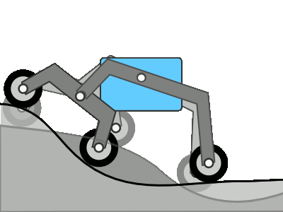
9. Figure: Rocker-Bogie suspension

Comparison
Off-road suspensions on Earth are primarily designed to provide stability, comfort, and handling over rough, uneven, or rugged terrain. These systems use components like coil springs, leaf springs, shock absorbers, and air suspensions to absorb shocks and vibrations from bumpy roads, rocks, mud, or sand. The main goal is to maximize traction, comfort, and vehicle control while maintaining good ground clearance for obstacles. Off-road suspensions often incorporate adjustable features to adapt to varying load conditions and terrain types. Earth-based systems also need to account for gravity, atmospheric pressure, changing weather conditions, and environmental wear and tear, requiring regular maintenance and durability.
Space suspensions are designed for use in environments with low or zero gravity, where the challenges of handling and mobility differ drastically. Space suspensions, such as those used in rovers on the Moon or Mars, focus on ensuring that the vehicle remains stable and maintains contact with the ground, which may be rocky, dusty, or uneven. Unlike Earth-based suspensions, space suspensions must withstand extreme temperature fluctuations, vacuum conditions, and low-gravity environments. They are typically simpler in design and lighter to reduce the overall weight of the vehicle, with a strong emphasis on durability and long-term reliability since space vehicles are rarely serviced. The lack of gravity means that space suspensions don’t need to deal with traditional shock absorption. They must deal with stability, traction, and protection from environmental extremes.

Project goals and requirements
This project aims to design and build a non-motorized vehicle while adhering to specific technical and functional constraints. The primary goals include:
- Comprehensive Planning and Design: Developing a detailed project plan, conducting literature reviews on suspension systems and off-road vehicles (e.g., Mars and Moon rovers), and proposing at least three suspension concepts, one of which will be selected via a decision matrix.
- Engineering and Fabrication: Creating detailed designs for 3D-printable parts using CAD or manual design methods, as well as designing and integrating additional components to complete the vehicle.
- Documentation and Deliverables: Producing comprehensive documentation that includes team roles, literature references, conceptual designs, decision matrix details, the finalized concept, a budget plan, component list, and technical drawings (individual and assembly).
Requirements and Constraints
- Physical and Dimensional Constraints:
  - Total vehicle dimensions must not exceed 28 × 14 × 14 cm.
  - Maximum dimensions for 3D-printed parts are 20 × 14 × 14 cm, with a limit of 20 pieces.
  - Wheel diameter is capped at 8 cm but may be self-designed.
  - The vehicle’s self-weight must remain below 0.6 kg.
- Functional Specifications:
  - The vehicle must accommodate a flat surface for attaching additional mass (up to 1 kg) and an acceleration sensor.

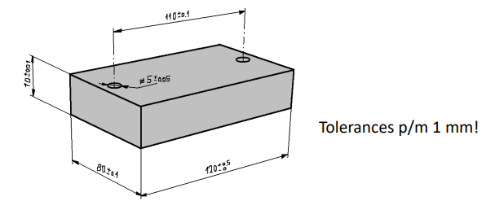
10. Figure: Additional weight specifications

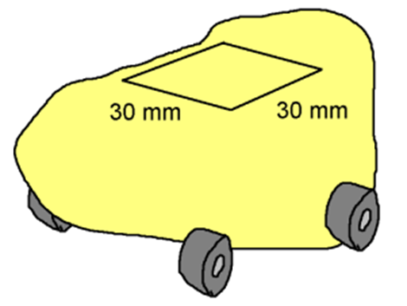
11. Figure: Acceleration sensor specifications

  - A towing cable attachment is required with a minimum 5 mm inner diameter hook or clip.
  - Recycled materials are encouraged for sustainability.
- Budgetary Limits:
  - Costs for off-the-shelf non-3D-printed components must not exceed 12,000 HUF.
The vehicle design prioritizes functionality, low weight, and stability while ensuring ease of testing and adaptability for various conditions.

Progression reports

Milestone 1

- Short reviews on different types of suspensions based on research
Rocker-bogie suspension system
The rocker-bogie suspension system is a mechanical design used in planetary exploration rovers to help them navigate rough and uneven terrain. It features rocker arms and bogie wheels that move independently to maintain stability and allow the vehicle to handle obstacles without tipping over.
Leaf Spring suspension
This type of suspension could be seen as ancient since it was even used in roman times but it became better known to the world with the mass production of the ford model at which was equipped with a lead suspension. A leaf spring is one or more narrow, arc-shaped, thin plates that are attached to the axle and chassis in a way that allows the leaf spring to flex vertically in response to irregularities in the road surface
MacPherson Strut suspension
The MacPherson strut suspension is a widely used independent suspension system in modern vehicles, particularly in front-wheel-drive cars. It combines the shock absorber and coil spring into a single unit, known as the strut assembly. The system provides a simple, cost-effective, and space-saving solution for vehicle suspension, offering improved ride comfort and handling.
- Comparison of suspensions
The suspension types listed above were compared based on their benefits and drawbacks

- Decision matrix

1. Table: Decision matrix
As shown on the table above Rocker-Bogie suspension system seemed to be the best option for the project.

Milestone 2

V1 Rough design with Rocker-Bogie suspension
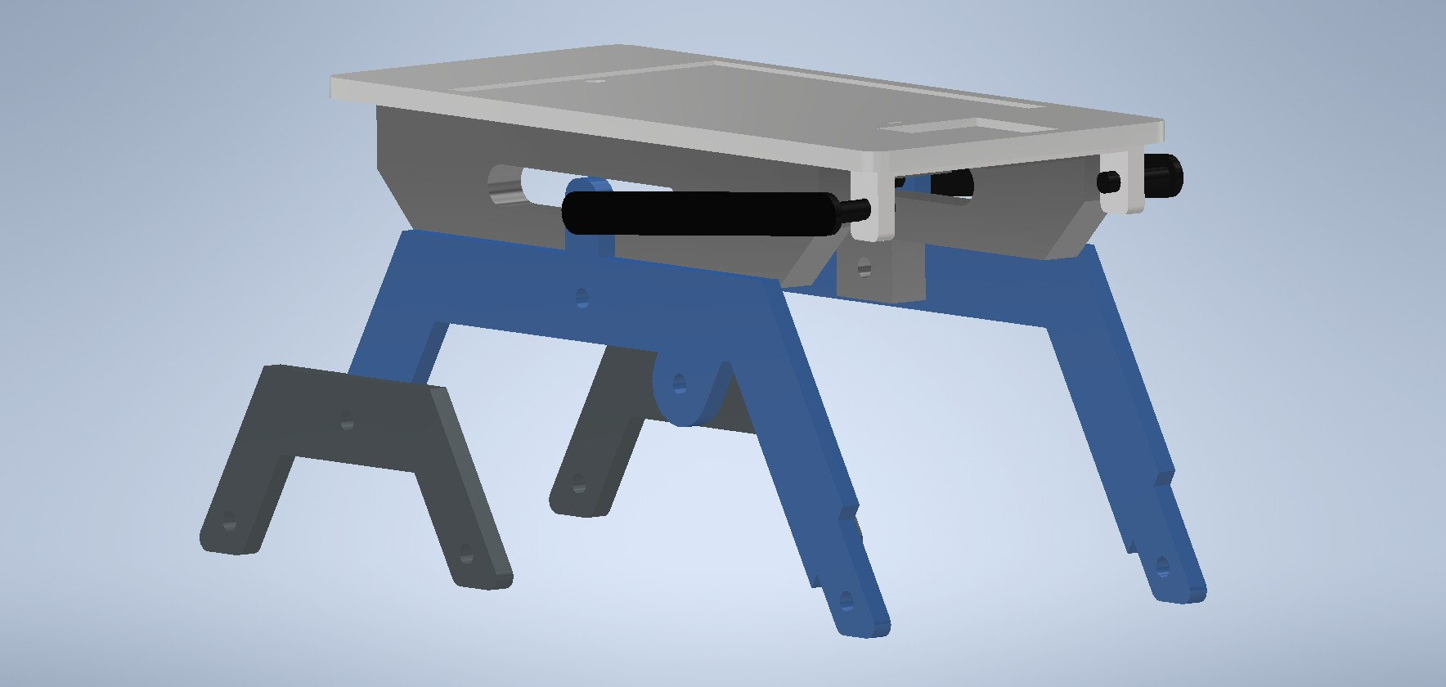
12. Figure: V1 Rough design

Early design of the 3D printed parts
- Flat surface plate
- Support housing
- Rocker arm
- Bogie arm
- Differential
  - Stabilizer pivot
  - Pivot mount
Additional components
6 wheels: 3 on both sides
- Parameters of the wheel
  - Diameter: 52.5 mm
  - Width: 20 mm
- Approximate cost: 4320HUF – 720HUF/wheel
- Where to get: Temu

Milestone 3

V2 Design
Fundamental changes were made to the V1 design considering its problems. These changes include lowering the center of mass, simplificating the design and making the joints durable. Wheels, screws, nuts and washers were also added to the 3D model.
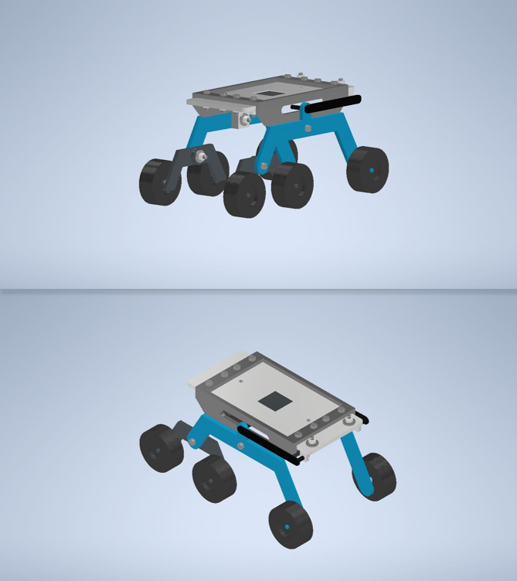
13. Figure: V2 Design
The upper plate of the vehicle was changed so that the additional weight can be attached under the plate making the center of mass lower. As for the rocker and bogie arms weight reduction was the main idea. To reduce weight the arms’ size and design was changed and wheel mounts were added to them. Also on the Bogie arm the screw joint was strengthened making it thicker.

Screws used for the design

- Screws: DIN EN ISO 1207
  - M3x10/10pcs
  - M3x16/2pcs
  - M3x8/2pcs
  - M3x25/1pcs
  - M3x20/2pcs
- Nuts: AS 1237 (3.1) 3 mm/17pcs
- Washers: DIN EN 24036 M3/17pcs

Milestone 4
V3 Final design
Some changes were made compared to the V2 design including the differential and the sizes of the screws, nuts and washers. Most of these changes aimed to make the construction easier, more economic, while the differential was redesigned because it was not optimal for the design.

Length: 267.122 mm
Height: 130.25 mm
Width: 138 mm
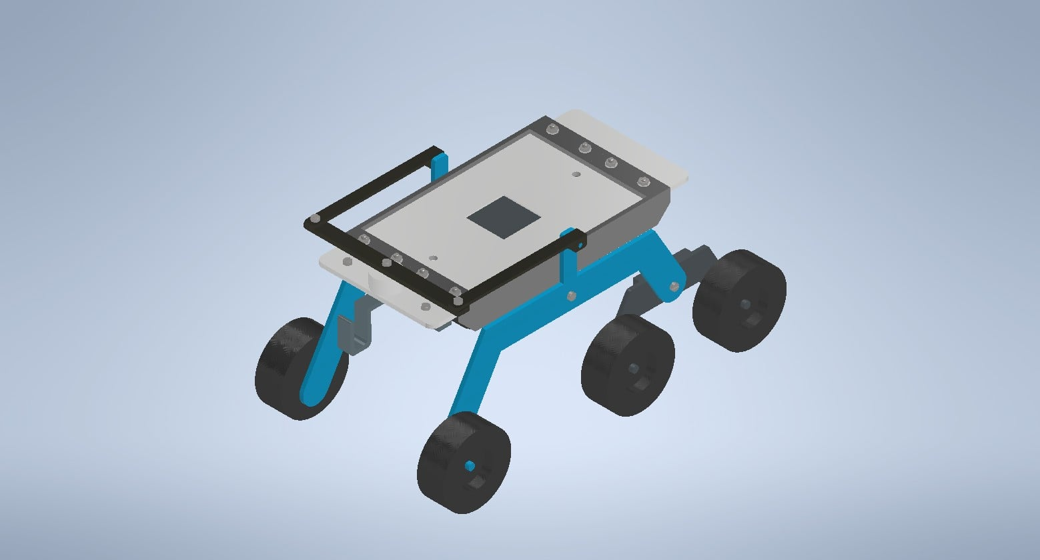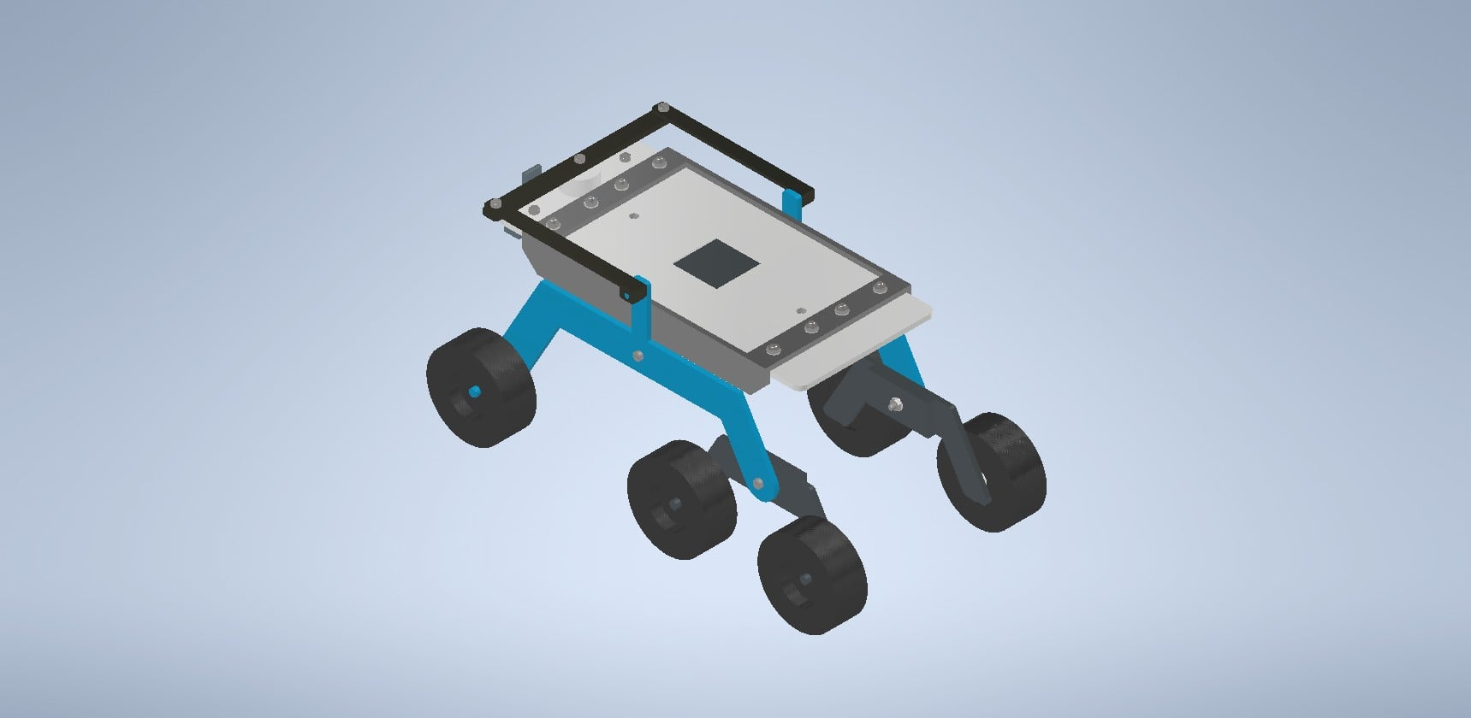
14. Figure: V3 Final design

Budget plan
Assembly plan
Prepare the Base Frame
Assemble the Rocker-Bogie Arms
- Attach the rocker arms (blue rocker arms) to the chassis using appropriate bolts and pivot points.
- Secure the bogie arms (smaller black arms) to the main rocker arms using the provided pivot mechanisms.
Attach the Wheels
- Insert the axles into the wheels.
- Attach the wheels to the rocker-bogie arms on both sides. Ensure the wheels are tightly secured and rotate freely.
Install the Support Brackets
- Attach the black support brackets on the top of the chassis using screws or bolts.
- These brackets may be used for stability or to hold additional components.
Final Tightening and Testing
- Check all bolts, screws, and pivots to ensure they are secure.
- Test the assembly by moving the suspension to ensure smooth and independent movement of the wheels.

Sources
Microsoft Word - CP-2004-212073.DOC
https://sandersonleafsprings.co.uk/leaf-spring-advantages-and-disadvantages
https://en.wikipedia.org/wiki/MacPherson_strut
https://www.carparts.com/blog/what-is-a-macpherson-strut-suspension-plus-other-related-faqs/
https://aldanamerican.com/blog/6-facts-about-the-macpherson-strut-you-can-impress-your-friends-with/
https://ateupwithmotor.com/terms-technology-definitions/macpherson-strut-history/
https://automotiveamerican.com/2024/10/14/earl-macpherson-and-the-macpherson-strut-suspension-system/

